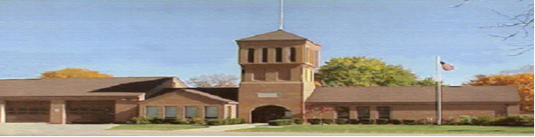

*Please attach any documentation, emails or notes to accompany this notification and return to Manchester Township office. Make sure that your contact information and preference for response is noted.*

**Email:**

Forwarded to: (Dept. / Representative)

Preferred method of communication:

Date of response: Citation issued? Y N

**Name:**

**Address:**

**Phone:**

Please provide your expectations for a solution:

Please describe the nature of your concern:

Received by:

Date:

Action/response:

Thank you for sharing your concerns with Manchester Township, our mission is to manage and maintain the Township as a safe and comfortable place to live. We are committed to work with you in a manner that protects the standards of all individuals involved under the guidelines of state and local laws and zoning guidance in an effort to reach a satisfactory solution to this situation. Your concerns will be directed to the appropriate official or department and you will receive an update within ten business days by your preferred method of communication. Thank you, your concerns are helping all residents experience a better quality of life in Manchester Township.

Date of complaint: